1877 1st Avenue Prince George, BC

250-563-5014

Email: [itspartytimepg@gmail.com](mailto:itspartytimepg@gmail.com)

Website: www.itspartytimepg.net

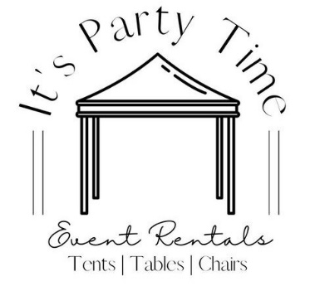

**Rental Price List**

**Tableware**

Gold Dinner Plates 10.5” $8.00/10

Gold Side Plates 7.5” $8.00/10

Gold Bread & Butter Plates 7” $8.00/10

Gold Soup Bowls $8.00/10

Gold Nappie Bowls $8.00/10

Gold Coffee Mugs $8.00/10

Gold Teacups $8.00/10

Gold Coffee or Teacups W/Saucers $8.00/10

White Dinner Plates 10” $8.00/10

White Side Plates 7” $8.00/10

White Soup Bowls 15oz $8.00/10

White Coffee Mugs $8.00/10

White Ramekins 4oz $8.00/10

Salt & Pepper Shakers $1.75/Set

*Gold w/White, White, Clear w/Silver*

**Cutlery & Serving Utensils**

Dinner Forks $7.00/10

Dinner Knives $7.00/10

Dessert Forks $7.00/10

Teaspoons $7.00/10

Steak Knives $7.00/10

Soup Spoons $7.00/10

Soda Spoons $7.00/10

Fork/Knife/Teaspoons $12.00/10

Fork/Knife/Dessert Forks $12.00/10

**\*Includes 10 forks, 10 knives, & 10**

**Teaspoons or Dessert Forks for $12.00\***

Gold Dinner Forks $12.00/10

Gold Dinner Knives $12.00/10

Gold Dessert Forks $12.00/10

Black Dinner Forks $12.00/10

Black Dinner Knives $12.00/10

Black Dessert Forks $12.00/10

Meat Fork $1.90ea

Tongs $1.90ea

Serving Spoons $1.90ea

Ladles $1.90ea

BBQ Flipper $2.50ea

**Charger Plates**

Gold Round 13” $1.00ea

Silver Round 13” $1.00ea

Silver Glass Pebble 12” $5.00ea

**Glassware**

Champagne Flutes 6oz $10.20/12

Wine Glasses 6oz $9.60/12

Wine Glasses 8oz $9.60/12

Wine Glasses 16oz $10.20/12

Hiballs 8oz $9.60/12

Stemmed Hiballs 8oz $9.60/12

Old Fashioned 7 1/4 oz $9.60/12

Pilsner Beer 11oz $9.60/12

Stemmed Water Glasses 12oz $9.60/12

Stemmed Water Goblets 10.5oz $9.60/12

Dark Blue Rosalie Goblet 8oz $21.00/12

Pressed Wine Glass 10.5oz $21.00/12

*Blue, Clear & Black*

Liqueur Glasses 1oz $1.25/5

Margarita/Fiesta Glasses 9oz $9.60/12

Martini Glasses 9 1/4oz $9.60/12

Milkshake Glasses 11.5oz $4.80/12

Plastic Kids Glasses 6oz $6.00/12

**Coffee Urns & Carafes**

Hot Water Boiler 33 Cup $20.00

Tea Urn 36 Cup $18.00

Coffee Urn 36 Cup $18.00

Coffee Urn 89 Cup $22.00

Coffee Urn 100 Cup $22.00

**\*CANNOT Be Used for Hot Chocolate\***

Coffee Carafes 64oz $5.00

Insulated Thermal 5gal $25.00

Insulated Crème Carafe 1 Ltr $5.00

Cream & Sugar Bowls $2.00

Teapots $5.00

**\*DO NOT plug urns into**

**extension cords or power bars\***

**Chafing Dishes**

Regular Chafing Dish $22.00

*Includes Lid, Water Bath, Food Insert*

Extra Food Inserts $6.00ea

*Full Deep

*Full Shallow

*Half Deep

*Half Shallow

Sterno (Burn Time 2.5hrs) $6.75ea

Roll Top Chafing Dish $22.00

Round Roll Top Chafing Dish $22.00

**BBQ’s, Pig Roaster & More**

BBQ 3’ $150.00

* 20lb Propane Tank $7.00
* Added Griddle Top $20.00

Griddle 3’ $150.00

* 20lb Propane Tank $7.00

Single Burner $25.00

* 20lb Propane Tank $7.00

Pig Roaster $150.00

* 30lb Propane Tank $10.00

**\*Tow behind; 2in ball required**

**City limits only\***

Rotisserie (Motorized) $30.00

BBQ Flippers $2.50ea

Meat Grinder $40.00

20lb Propane Rental $7.00

30lb Propane Rental $10.00

**All propane tanks MUST be**

**refilled on return.**

**You can also use your own**

**tank instead of renting one of ours.**

**Portable Bars, Cooking Pots & Misc**

Portable Bar (Grey) $100.00

Portable Bar (Folding) $100.00

Chocolate Fountain $75.00

*3 Tiered; Chocolate NOT included*

Stock Pots $15.00

Meat Lamp 500Watt $17.00

Soup & Gravy Warmer $20.00

Lobster Butter Warmer $2.00

Lobster Cracker $0.75

**Beverage Supplies**

Beverage Fountain 5gal $50.00

Stainless Steel Punch Bowl 5gal $22.00

Acrylic Punch Bowl 5gal $25.00

Wine Carafes ½ Ltr $1.75ea

Wine Carafes 1 Ltr $2.00ea

Accupours 1oz $2.50ea

Plastic Pitchers $2.75ea

Keg Pump $25.00

*Domestic Beer Only*

Small Galvanized Ice Bucket w/Stand $20.00

Beverage Containers 5gal $14.00

Acrylic Beverage Container 5gal $30.00

*W/Stainless Steel Ice Cooler*

Galvanized Ice Tubs 2x2x3 $30.00

Galvanized Ice Tubs 2x2x4 $30.00

Galvanized Ice Tubs 2x2x5 $30.00

**Serving Bowls, Trays & Platter**

X-Sm Acrylic Bowl $2.00

Sm Acrylic Bowl $6.00

Med Acrylic Bowl $6.00

Stainless Steel Veggie Bowl $20.00

Oval Stainless-Steel Serving Tray 16” $4.00

Oval Stainless-Steel Serving Tray 18” $6.00

Oval Stainless-Steel Serving Tray 20” $8.00

Oval Stainless-Steel Serving Tray 24” $10.00

Gold Trim S/S Serving Tray 10” $6.00

Gold Trim S/S Serving Tray 15” $8.00

Gold Trim S/S Serving Tray 20” $10.00

Gold Trim S/S Serving Tray 25” $12.00

Round S/S Serving Tray 15” $6.00

Round S/S Serving Tray 20” $10.00

Round Non-Slip Bar Trays 16” $3.00

3-Tiered Wood Tray $15.00

3-Tiered Stainless-Steel Tray $20.00

Glass Riser Serving Tray $20.00

*W/Iron Stand 23”L x 16” W

*W/Iron Stand 24” L Oval

**Candy Bar Supplies**

Candy Bar Dispenser $60.00

*9 Dispensers Included*

Small Metal Scoops $1.50

Black Plastic Tongs $1.50

Clear Plastic Tongs $1.50

**Champagne Wall**

Champagne Wall W/ 36 Glasses $75.00

*Holds 21 Glasses*

**Cupcake Stands $/Holds**

3-Tiered Wood & S/S $15.00

4-Tiered Wood $30.00

4-Tiered Round White $25.00/70

4-Tiered Square White $25.00/75

5-Tiered Round White $25.00/150

5-Tiered Round Silver $25.00/150

5-Tiered Square White $25.00/150

5-Tiered Square Bronze $25.00/150

7-Tiered Round White $30.00/80

3-Tiered Round S/S Floor Stand 4.5ft $100.00/200-300

5-Tiered Round Black $25.00

*W/ Glass or Wood Trays*

**Cake Stands**

Cake Stand W/ Rotating Base $25.00

Round Stainless-Steel Cake Stand 14” $20.00

Square Diamond Cake Stand 18” $45.00

*Silver, Black or White*

Round Diamond Cake Stand Black 18” $45.00

3-Tiered Cake Stand $25.00

*W/ Stainless-Steel Gold Trim Trays*

Live Edge Wood Cake Stand 11” $10.00

Round Galvanized Cake Stand 12” $10.00

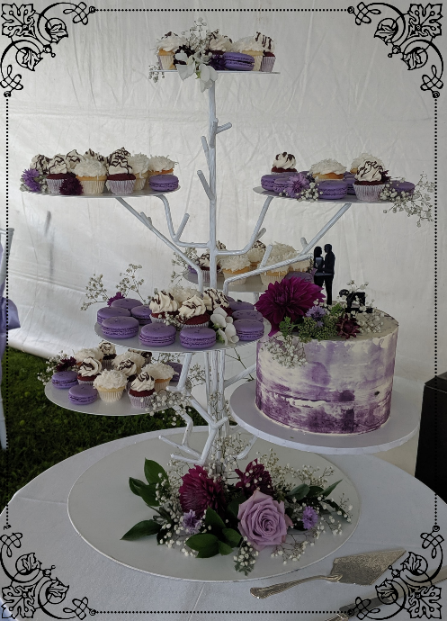

**7-Tier Round White Cupcake Stand; $30.00/Holds 80 Cupcakes**

**Centre Pieces & Decor**

Table # Holder 12”H $2.00ea

Wood Table # Holder W/Stand $2.00ea

Wood Rounds 12” $2.00

Wood Frame 11” Tall $5.00

Stemmed Glass Candle Set 3pc $12.00

Glass Vase W/Glass Top 8” $5.00

Glass Hurrican Vase 10”H x 7.5” D $9.00

Glass Quadra Vase 6” x 6” $6.00

Glass Pedestal Bowl 5.5”H x 8”D $6.00

Glass Cube Vase 5.5”Sq x 6.5”H $8.00

Glass Chantal Votive Candle Holder $2.00

Birch Vases 9” $2.00

Birch Vases Whitewash 6” $2.00

Geometric Glass Gold Sq. Terrarium $3.00

Geometric Glass Gold Tri. Terrarium $3.00

Geometric Hanging Vase Sm/Lg $4.00

Geometric Tall Gold Centre Piece $4.00

Geometric Candle Holders $4.00

Geometric Rose Gold Candle Holder $4.00

Geometric Black Tall Candle Holders $4.00

Geometric Black/Gold Hanging Lantern $4.00

Candle Sticks - Brass Assorted $3.00ea

Candle Sticks - Gold Assorted $3.00ea

Lantern - Metal Cream W/Bling $5.00

Lantern - Wooden Hanging $8.00

Lantern - Stainless W/Glass Panels $2.00

Lantern - Birch W/Star Cutouts $2.00

Lantern - Wood 12” Tall $8.00

Crystal Votive Tea Light Holder 4” $2.50

Crystal Candle Holders $8.00

*Sizes: 9”H, 14”H & 16.5”H*

Cylinders 3.5” Diameter $4.00

*Sizes: 6”H, 7.5”H, 9”H & 10.5”H*

Cylinders 4” Diameter $5.00

*Sizes: 20”H*

Cylinders 4.5” Diameter $5.00

*Sizes: 10”H*

Cylinders 6” Diameter $5.00

*Sizes: 20”H*

LED Vase Light $5.00

3 pc Glass Taper candle holders $5.00ea

w/ glass chimney

**Table Candelabras**

Candle Stands $75.00

*5-Tiered W/ Chimney Tops 29”H*

4 Candle Candelabra $15.00

*Silver 30”H W/Floral Bowl*

5 Candle Brass Candelabra $5.00

Plastic Gold Candelabra $10.00

*24”H W/Floral Bowl*

Clear Crystal Candelabra $95.00

*30”H W/Carrying Case

**Rustic Decor**

Wooden Crates $6.00

*Brown; 5 Sizes*

Wooden Crates W/Slats $5.00

*Brown; 3 Sizes*

Old Wooden Doors 78”H x 29”W $75.00

Wooden Ship Barrels $12.00

Wagon Wheel 32” $20.00

Wagon Wheel Black 35” $20.00

Ladders Vintage White 5.5’ $20.00

Foam Stump W/Wood Veneer 8”H $5.00

Foam Stump W/Wood Veneer 12”H $7.00

**Chandeliers**

Chandelier Beaded Silver $45.00

*24”D x 18”L*

Chandelier Beaded Silver $75.00

*24”D x 6’L*

Chandelier 5 Light Bronze $50.00

*25.5”W x 24.5”H*

**Monetary/Card Holders**

White Wishing Well W/Clear Lid $35.00

Acrylic Bling Box W/Lid 10” x 10” $35.00

White Mailbox Card Holder $25.00

Antique Bird Cage Sm 18” $10.00

Antique Bird Cage Lrg 23” $15.00

*W/Floral Base & Twig*

Gold Geometric Card Holder $15.00

Vintage Wood W/Glass Hinge Top $20.00

**Draping & Backdrops**

Backdrop Bars Upright 7-10ft $10.00

Backdrop Bars Upright 9-16ft $10.00

Backdrop Bases 18”x18” $10.00

Backdrop Bars Cross 7-12ft $10.00

Backdrop Bars Cross 8-14ft $10.00

Backdrop Bar Extender 3” $1.00

Backdrop Bar Extender 9” $1.00

Spandex Pole Cover Ivory $5.00

Spandex Pole Cover White $5.00

**Sunlight Panels**

Sunlight Panel Backdrop $180.00

*3 Section White Sheered 8’H x 12’L*

Sunlight Panel 7’H x 4’L $60.00

Sunlight Panel 8’H x 4’L $60.00

Sunlight Columns 5’H $20.00

**Columns/Pillars**

2’ White Pillars $12.00

3’ White Pillars $15.00

4’ White Pillars $15.00

5’ White Pillars $17.00

6’ White Pillars $20.00

Light Bases for Pillars $7.00

Iron Pillars 7’ $25.00

5 pc white metal rect stands $175.00

**Off The Wall**

Large Arch Way 12’H $300.00

Scroll $10.00

Ball Topper $10.00

Cake Table $50.00

Floral Vases W/Flowers $30.00

Arch Way 6’ Pillars $45.00

Bench Pieces $15.00

Chair $15.00

1’ Pillar $10.00

2’ Pillar $12.00

3’ Pillar $15.00

**Lights**

Star Gazer LED $40.00

Mirror Ball Small $50.00

Mirror Ball Large $75.00

String Lights 48’ LED $25.00

Floor 4-Globe Lights White $25.00

**Arches**

Double Triangle Arch $120.00

Iron Bronze Arch $75.00

Cape Wind Arch Way White $100.00

Cedar Square Arch $100.00

Circle Tension Arch $175.00

*Reversible White & Black Cover*

**Register Stands & Easels**

Candelabra Willow Tree (Pair) $50.00

*W/Glass Hanging Cups 16*

Register Stand Brass $15.00

Register Stand White Lattice $20.00

Register Stand White Chrome $25.00

Brass Easels $20.00

Easel 6’ $35.00

*Black or White*

**Floral Decor**

Uneven Floral Stands (pair) $100.00

*W/Floral Greenery*

Metal Frame Stands $40.00

*Gold or Silver*

Urns White Plastic W/Floral $25.00

Harlow Plant Stands $75.00

*Twig, White Pot & Floral*

Trumpet Vases Aluminum 45” $55.00ea

Eucalyptus 3’ $3.00

Eucalyptus Light Up Garland 9’ $25.00

6’L Greenery Willow Leaf $20.00

Floral Swag 30” $20.00ea

*Pink Peonies, White Peonies,

Eucalyptus, Hot Pink, Sunflowers,

Light Blue, Fall Roses*

Floral Swag Sets $35.00ea

Floral Pink Rose & Peonies 26” $20.00

Twig Garland Brown 5’L $4.00

Twig Green Moss Garland 35” $2.00

Twig Moss Spray 36”H $2.00

Twig Green 27”H (Moss Twig Bush) $1.50

Twig Brown 58”H (Twig Spray x 3) $1.00

Twig Large Squares W/Floral $5.00

Twig 48” LED Brown Twig Branch $10.00

Twig/Greenery/Peonies $20.00

Twig/Greenery/Fern $20.00

Sunflower Trees - 48”H 3 Flowers $15.00

Sunflower Trees - 60”H 3 Flowers $15.00

Sunflower Trees - 72”H 3 Flowers $15.00

**Chalkboard Signs & Wood Signs**

Chalkboard Oval Signs $7.00

”Thank you for being a part

of our special day”

“Cards”

“Bar”

Chalkboard Table Numbers $1.00

*W/Iron Stand*

Chalkboard Sign $15.00

“Best Day Ever”

Chalkboard Sign $10.00

“Candy Bar”

“Popcorn Bar”

Chalkboard Standing Signs $25.00

“Welcome to our

unplugged ceremony…”

“Welcome… “Thank you…”

“This day I will marry my friend…”

“Today two families become one…”

“Welcome to the best day ever…/

Thanks for coming”

Chalkboard Standing Sign (White) $15.00

“Welcome to our wedding”

Chalkboard Window 29”H $15.00

Mirror White Floor Standing $55.00

“Thank you…”

Chalkboard Barn Door Sign Small $15.00

Chalkboard Barn Door Sign Large $25.00

Chalkboard Mini Signs $5.00

“Bar “Cards “Mr “Mrs “Candy Bar”

Please sign our guestbook”

Chalkboard Swing Sign Brown $55.00

“Welcome to our

unplugged… “Thank you…”

Chalkboard Swing Sign White $55.00

“Today two families… “Thank you…”

Chalkboard Frame Large W/Stand 4.5ft $35.00

Table Letters White “Mr & Mrs” $20.00

Table Letters White “Cards” $15.00

Table Letters White “Bar” $15.00

“Mr & Mrs” Neon Hanging Sign $60.00

*Light Up*

**Linen**

**8’ (60x120) Rectangular Polyester** $12.50

*White, Ivory, Black, Silver, Navy,

Red, Brown, Tan, Pink & Purple*

**8’ (60x120) Rectangular Majestic** $12.50

*Ivory, Silver & Tan*

**120” Round Polyester** $12.50

*White, Ivory, Black, Silver, Navy,

Cherry Red, Brown, Tan, Pink, Purple,

Deep Royal Blue & Hunter Green*

**120” Round Majestic** $12.50

*Charcoal*

**120” Round Miranda Damask** $19.00

*English Rose & Champagne*

**90” Round Polyester** $12.50

*White, Ivory, Black, Silver, Navy,

Cherry Red, Pink, Yellow, Periwinkle,

Teal & Burnt Orange*

**90” Round** **Havana** $12.50

**90x156 Rectangular (To the Floor) Poly.** $19.00

*White, Ivory, Black, Navy,

Brown & Pink*

**90x156 Rectangular (To the Floor) Maj.** $19.00

*Silver, Tan, Camel, Charcoal,

Purple &Lime Green*

**90x156 Rectangular Miranda Damask** $25.00

*Champagne*

**90x156 Rectangular Havana** $25.00

**Spandex Table Covers** $15.00

*36” Round W/42” Leg*

**Napkins Polyester** $1.25

*White, Ivory, Black, Silver, Navy,

Cherry Red, Pink, Blush Pink, Lilac,

Purple, Eggplant, Burgundy, Terracotta,

Deep Royal Blue, Slate Blue, Teal,

Hunter Green, Sage Green, & Charcoal*

**Placemats** $2.50ea

*Havana Ivory & Natural and

Silver, Red & Burgundy Polyester*

**Runners 10’ W/Sq Ends Polyester** $6.50

*White, Ivory, Black, Silver, Navy,

Cherry Red, Brown, Pink, Hot Pink,

Dusty Rose, Purple, Light Yellow,

Burgundy, Terracotta, Burnt Orange,

Orange, Lite Blue, Royal Blue &

Hunter Green *

**Runners 10’ W/Sq Ends Majestic** $6.50

*Black, Silver, Eggplant, Turquoise,

Gold, Lime Green & Sage

**Runners Havana Natural 14” x 120”** $7.00

**Runners Chantilly Lace** $6.50

*White, Ivory & Blush Pink*

**Runners Chiffon 27” x 120”** $7.00

*White, Black, Ivory, Navy, Dusty Rose,

Blush Pink, Burgundy & Dusty Blue*

**Runners 13” x 108” Crushed Taffeta** $6.50

*Champagne & Tiffany Blue*

**Runners Velvet 13”x108”** $7.00

*Navy, Dusty Rose, Burgundy,

Dusty Blue, Emerald Green*

**Table Skirts**

Shirred Majestic 21ft $50.00

*White, Ivory, Black & Navy*

Shirred Polyester 21ft $50.00

*Purple*

Rosette 14ft Ivory $40.00

Rosette 17ft Black $40.00

Rushed 13ft $40.00

*White & Ivory*

Rushed 14ft $40.00

*Plum, Blush, Brown & Champagne*

Ruffled 13ft White $40.00

Shirred Havana Natural 14ft $40.00

**All linen must be free of food &**

**confetti when returned!**

**There will be a replacement charge**

**for any damaged linen.**

**We need to know the thickness of**

**the table you would like to use the**

**skirts on so the clips we provide will fit.**

**Satin Chair Sashes** $0.75

*White, Ivory, Black, Black Crinkle,

Silver, Navy, Red, Gold Crinkle,

Champagne Crinkle, Blush Pink,

Pink, Hot Pink, Peach, Mauve,

Lilac, Purple, Teal & Turquoise*

**Chair Sash Majestic** $1.50

*Ivory & Purple*

**Sash Miranda Damask** $1.50

*Champagne*

**Chair Covers**

Folding $3.00

*White & Black*

**Back Drop Panels**

Chiffon Off White 60” x 9ft $20.00

Chiffon Off White 20’ Swag $25.00

Chiffon Off White 40’ Swag $30.00

White Brulee Shirred 60” x 9ft $20.00

White Somerset 73” x 10ft $25.00

White Sequin 96” x 8ft L $15.00

Black Sequin 96” x 8ft L $15.00

Silver Sequin 52” x 10ft $30.00

Havana Natural 58” x 10ft L $20.00

Purple Satin 60” x 8ft L $15.00

Spandex Blush Pink 60”W x 10ft $20.00

Spandex Light Blue 60”W x 10ft $20.00

Spandex Black 60”W x 10ft $20.00

White Crushed Velvet 60” x 12’ $20.00

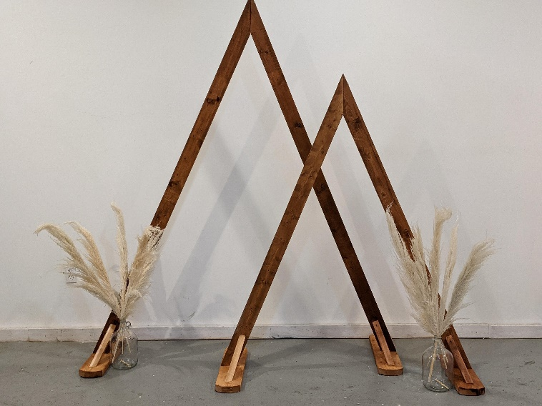

**Double Triangle Arch $120.00**

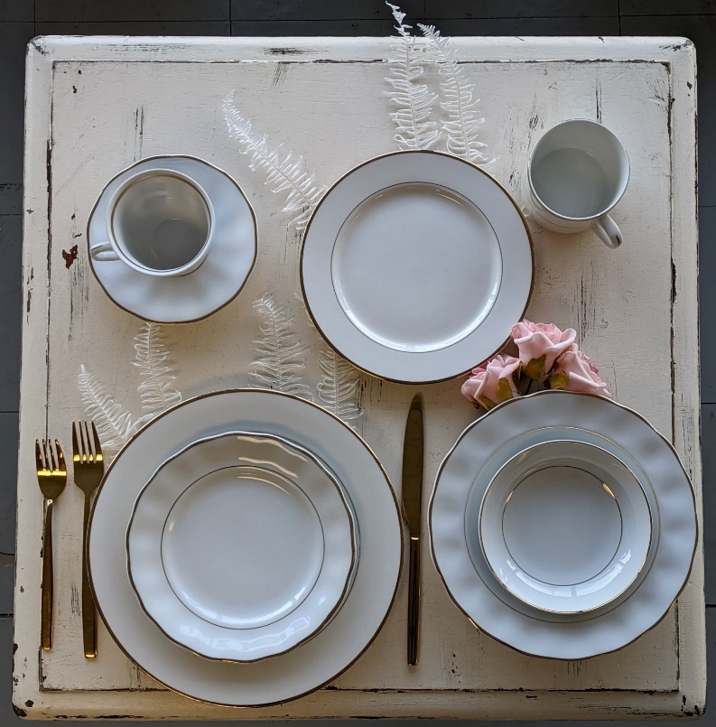

**White & Gold Tableware with Gold Cutlery**

**Farm Table, Gold Tableware, Silver Cutlery, Dark Blue Rosalie Goblet, White Napkins, Off-White Chiffon Swag, Light Up Eucalyptus, Cylinders.**

**\*We no longer rent chiavari chairs\***

**Games, Concession & More**

**Kids Games**

**Case Games** $50.00

* Monster Head Knockdown
* Balloon Pop

*Balloons needed;

we don’t supply them*

* Earthworm Round Up
* Fish in a Bowl
* Kracken Ring Toss

*Needs to be plugged in*

* Clown Tooth Knockdown
* Tic-Tac-Toe
* Can Smash

**Standing Games**  $75.00

* Juggling Rings Clown
* Pin the Tail on the Donkey
* Magnetic Balloon Dart
* Plinko

**Tabletop Games**

* Connect 4 32”H $50.00
* Magnetic Dart Game $50.00
* Under the Knife (Operation) $140.00

6ft Long

Kiddie Striker Dinosaur 7.5ft Tall $50.00

*Kids 10 & Under only*

Mini Golf $35.00

Laser Tag $120.00

*6 guns total*

**All kids’ games are rent one game &**

**get another game at ½ price!**

**\*SECOND GAME MUST BE**

**OF SAME OR LESSER VALUE\***

**Selfie Booth** $175.00

Frame 5’W x 4.5’D x 7’H

Black Drapes, Valance & Sign

* Selfie Booth Sign Beach
* Selfie Booth Sign Fireworks
* Selfie Booth Sign Kissing Booth
* Selfie Booth Sign Mirror Ball
* Selfie Booth Sign Wanted
* Selfie Booth Sign Christmas Scenery

**Poker Games & More**

* Texas Hold Em Table $60.00
* Blackjack Table $60.00
* Roulette Table $60.00
* Chip Sets 500 Chips & Cards $7.00
* Colored Spinning Wheel 36” $36.00
* Raffle Drum $26.00

**Yard Greetings**

Pink Flamingos $2.00ea

Skelo-Mingos $2.00ea

Happy Birthday Letters, Age & Ballons $85.00

*24 assorted balloons*

**We take a damage deposit on the**

**“Happy Birthday” yard greeting sign,**

**which we refund once its returned intact.**

**We also DO NOT set up the yard greetings,**

**you must set up yourself.**

**Concession & Carnival Machines**

Hot Dog Machine $35.00

Popcorn Machine $100.00

All in one Popcorn $3.80ea

*Coconut Oil, Seasoning & Kernels*

Popcorn Bags $0.20ea

**Machines must not be plugged into**

**extension cords or power bars.**

Karaoke Machine $40.00

*Includes 1 cordless mic & CDs*

Bubble Machine $35.00

Balloon Inflator $6.00

Projector $100.00

*Epson HDMI/USB*

**DOES NOT WORK WITH**

**APPLE PRODUCTS**

Projector Tripod Screen 6’ $20.00

Cordless Microphone $25.00

Ceremony Scissors Large $35.00

Santa Suit $45.00

*Includes belt, hat, belly stuffer,

boot covers, jacket & pants*

**DOES NOT INCLUDE BEARD**

King & Queen Statues $100.00ea

Coat Racks W/ Hangers $25.00

* Small holds 75 coats
* Large holds 100 coats

**Tables**

6’ Rectangular $12.50

8’ Rectangular $12.50

30” Round Cocktail Table W/ 30” Leg $12.50

36” Round Cocktail $12.50

*30” or 42” Leg*

5’ Round $12.50

½ 5’ Round $12.50

¼ Serpentine $12.50

Vintage Table 30” $12.50

Kids Folding Table 24” x 24” $5.00

**Farm Style Tables**

Farm Table Cross Leg 40” x 8’ $105.00

*Only 2 available*

Farm Table Straight Leg 40” x 8’ $105.00

*Only 1 available*

36” Round 30”H $55.00

**Chairs**

White Folding Chrome $3.00ea

Black Folding Chrome $3.00ea

White Folding Resin Lawn $7.00ea

*W/Padded Seat*

Black Folding Resin Lawn $7.00ea

*W/Padded Seat*

Walnut Wood Folding $9.00ea

*W/Tan Padded Seat

Bar Stools Black Folding $7.00ea

White Tufted Diamond (Pair) $200.00

*Bride & Groom Chairs*

Kids Chairs Blue $1.25ea

*Ages 3-9*

**Portable Tow Behind Toilets**

Single Toilet $250.00

*Includes washing station, urinals,

garbage’s, hand soap, paper towel,

toilet paper*

Flushing and non-flushing available

**Tents**

10x10 Marquee Tents $375.00

Standard Sliding Wall $35.00

Sliding Window Wall $35.00

20x20 Marquee Tents $550.00

34x40 Hexagon Marquee Tents $1400.00

**\*These tents are only set up & taken**

**down by our crew, once they**

**are up, they cannot be moved\***

Zipper Door $55.00

Sliding Cathedral/Window Wall $55.00

Sliding Solid Wall $55.00

Rain Gutters $45.00

Sub Floor Grey $1.50/sqft

**Tent Lighting**

Chandelier White 4 Globe $25.00

Centre Pole Light 4 Globe $25.00

String lights 48’ $25.00

Chandelier Bronze 5 Lights $50.00

*25.5”W x 24.5”H (Dover 5)

**One Hexagon Tent & Two 20x20 Tents**

**with both Window & Solid Walls**

**Five 20x20 Tents with both Cathedral Windows &**

**Solid Walls**

**PRICES ARE SUBJECT TO**

**CHANGE WITHOUT NOTICE!**

**Delivery & Pickup Charges**

Out of town mileage to be quoted.

Minimum Regular $95.00 Delivery/

$95.00 Pickup Charge

(This only applies to within city limits.)

Applies to all regular scheduled deliveries/pickups placed.

For regular delivery & pickup charges to apply, orders must be delivered/picked up between our regular business hours between Monday-Friday 9am-4pm

**Please Note:**

Extra charges will apply depending on the equipment and number of workers required on delivery/pickups.

Our service is Door to Door, if there are any stairs or gates we must be notified & extra charges may apply.

If you have a scheduled delivery or pickup and we get there, and no one is there, or we are asked to come back you will be charged another delivery or pickup charge.

You must have everything packed up and removed from under the tents as well. We do not do any set ups or tear downs, besides our tents.

**50% Non-Refundable Deposit is Required on Bookings**