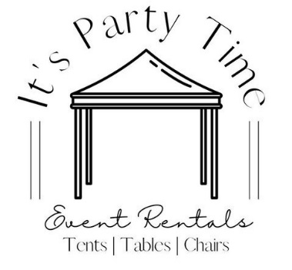
32 Guests
Basic Tent Packages
1877 1st Avenue Prince George, BC
250-563-5014
Email: itspartytimepg@gmail.com
Website: www.itspartytimepg.net

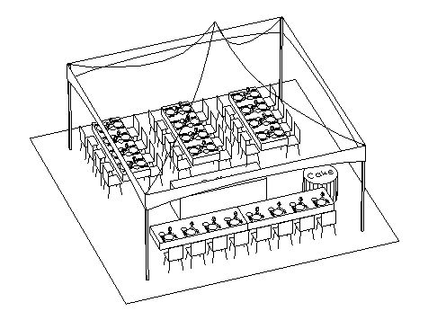
Package A:
1 - 20x20 Tent $550.00
4 - Walls $340.00
32 - White Chrome Chairs $96.00
6 - 8’ Rectangular Tables $75.00
4 - 8’ Rectangular Linen $50.00
2 - 90x156 Linen (Head table) $38.00
1 - 36” Round Table (Guest book) $12.50
1 - 90” Round Linen $12.50
40 - Dinner Plates $36.00
40 - Side Plates $36.00
40 - Fork/Knife/Dessert Fork $48.00
36 - 8oz Wine Glasses $32.40
Sub Total $1326.40
Discount (5%) $66.32
Package Price $1260.08 + Tax

32 GUESTS
Package B:
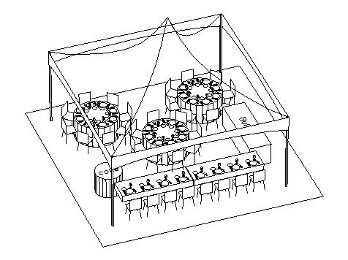
1 - 20x20 Tent $550.00
4 - Walls $340.00
32 - White Chrome Chairs $96.00
3 - 8’ Rectangular Tables $37.50
1 - 8’ Rectangular Linen $12.50
2 - 90x156 Linen (Head Table) $38.00
3 - 5’ Round Tables (Guest Tables) $37.50
3 - 120” Round Linen $37.50
1 - 36” Round Table (Guest Book) $12.50
1 - 90” Round Linen $12.50
40 - Dinner Plates $36.00
40 - Side Plates $36.00
40 - Fork/Knife/Dessert Fork $48.00
36 - 8oz Wine Glasses $32.40
Sub Total $1326.40
Discount (5%) $66.32
Package Price $1260.08 + Tax

72 Guests
Package:
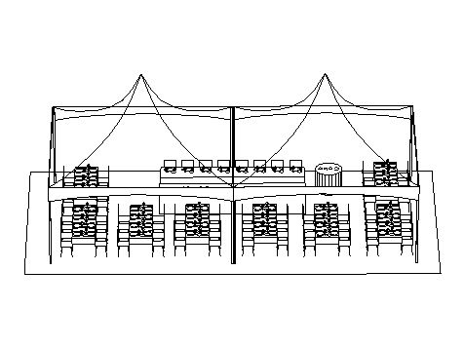
2 - 20x20 Tents $1100.00
1 - 20’ Gutter $70.00
6 - Walls $510.00
72 - White Chrome Chairs $216.00
12 - 8’ Rectangular Tables $150.00
10- 8’ Rectangular Linen $125.00
2 - 90x156 Linen (Head Table) $38.00
1 - 36” Round Table (Guest Book) $12.50
1 - 90” Round Linen $12.50
60 - Dinner Plates $54.00
60 - Side Plates $54.00
60 - Fork/Knife/Dessert Fork $72.00
60 - 8oz Wine Glasses $54.00
Sub Total $2468.00
Discount (5%) $123.40
Package Price $2344.60 + Tax

56 Guests
Package:
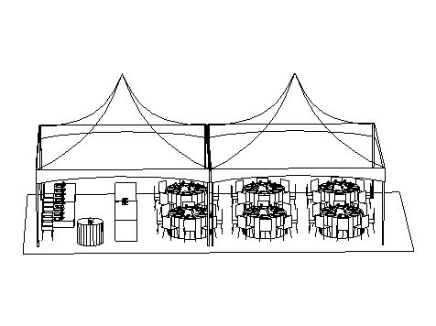
2 - 20x20 Tents $1100.00
1 - 20’ Gutter $70.00
6 - Walls $510.00
56 - White Chrome Chairs $168.00
6 - 5’ Round Tables $75.00
6 - 120” Round Linen $75.00
4 - 8’ Rectangular Tables $50.00
2 – 8’ linen $25.00
2 - 90x156 Linen (Head Table) $38.00
1 - 36” Round Table (Guest Book) $12.50
1 - 90” Round Linen $12.50
80 - Dinner Plates $72.00
80 - Side Plates $72.00
80 - Fork/Knife/Dessert Fork $96.00
72 - 8oz Wine Glasses $64.80
Sub Total $2440.80
Discount $122.04
Package Price $2318.76 + Tax

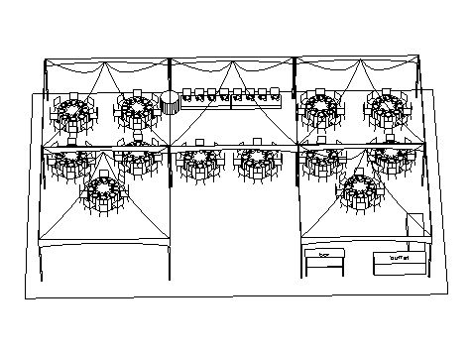
96-120 Guests
Package:
5 - 20x20 Tents $2750.00
4 - 20’ Gutters $280.00
9 - Walls $765.00
104 - White Chrome Chairs $312.00
12 - 5’ Round Tables $150.00
12 - 120” Round Linen $150.00
4 - 8’ Rectangular Tables $50.00
(2 Head Table, 2 Buffet)
2 - 8’ Rectangular Linen (Buffet) $25.00
2 - 90x156 Linen (Head Table) $38.00
1 - 36” Round Table (Guest Book) $12.50
1 - 90” Round Linen $12.50
Note: Adding 3 more 5’ Round Tables inside will increase your guests to 120
110 - Dinner Plates $99.00
110 - Side Plates $99.00
110 - Fork/Knife/Dessert Fork $132.00
108 - 8oz Wine Glasses $97.20
Sub Total $4972.20
Discount $248.61
Package Price $4723.59 + Tax

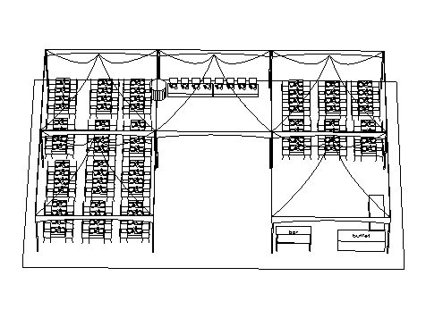
144-180 Guests
Package:
5 - 20x20 Tents $2750.00
4 - 20’ Gutters $280.00
9 - Walls $765.00
152 - White Chrome Chairs $456.00
22 - 8’ Rectangular Tables $275.00
20 - 8’ Rectangular Linen $250.00
2 - 90x156 Linen (Head Table) $38.00
1 - 36” Round Table (Guest Book) $12.50
1 - 90” Round Linen $12.50
You can increase your guests to 180 by seating 10 guests per table instead of 8.
160 - Dinner Plates $144.00
160 - Side Plates $144.00
160 - Fork/Knife/Dessert Fork $192.00
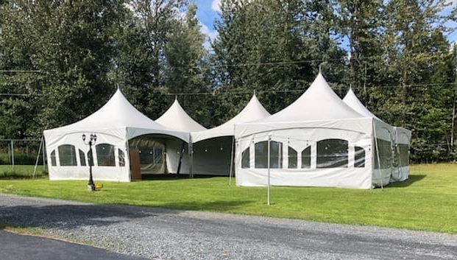
156 - 8oz Wine Glasses $140.40
Sub Total $5459.40
Discount $272.97
Package Price $5186.43 + Tax

168 Guests
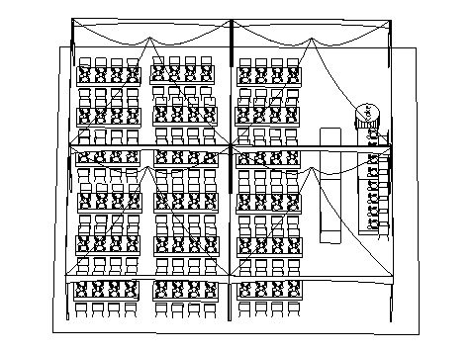
Package:
4 - 20x20 Tents $2200.00
1 - 4 Way Gutter Adapter $85.00
4 - 20’ Gutters $280.00
8 - Walls $680.00
168 - White Chrome Chairs $504.00
22 - 8’ Rectangular Tables $275.00
20 - 8’ Rectangular Linens $250.00
2 - 90x156 Linen (Head Table) $38.00
1 - 36” Round Table (Guest Book) $12.50
1 - 90” Round Linen $12.50
170 - Dinner Plates $153.00
170 - Side Plates $153.00
170 - Fork/Knife/Dessert Fork $204.00
172 - 8oz Wine Glasses $151.20
Sub Total $4998.20
Discount $249.91
Package Total $4748.29 + Tax

248 Guests
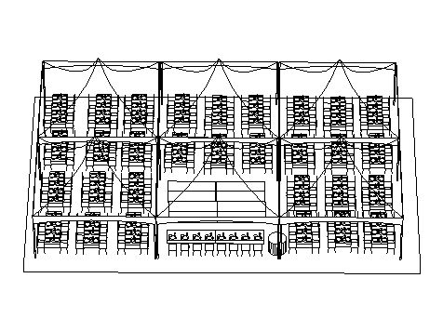
Package:
6 - 20x20 Tents $3300.00
2 - 4 Way Gutter Adapters $170.00
7 - 20’ Gutters $490.00
10 - Walls $850.00
248 - White Chrome Chairs $744.00
36 - 8’ Rectangular Tables $450.00
(Guest Tables, 2 Buffet Tables,
2 Head Tables)
34 - 8’ Rectangular Linen $425.00
2 - 90x156 Linen (Head Table) $38.00
1 - 36” Round Table (Guest Book) $12.50
1 - 90” Round Linen $12.50
250 - Dinner Plates $225.00
250 - Side Plates $225.00
250 - Fork/Knife/Dessert Fork $300.00
252 - 8oz Wine Glasses $226.80
Sub Total $7468.80
Discount $373.44
Package Total $7095.36+ Tax

50% Non-Refundable Deposit required on all bookings.
Delivery & Pickup Charges are not included in these prices,
as well as all applicable taxes & damage deposits.
Extra fees will apply on load size and distance as well.
Prices are subject to change without notice.

Notes:
You can change your tables to 8’ Rectangular and accommodate more guests.
All Linens are booked as white unless you request to have specific colors.
Provision should be made for food serving areas, bars, stages, display areas and any other specially designated space.
Please remember no two functions are the same. Each purpose deserves to be looked at individually so that the exact size of tent can be determined based on your personal needs and preferences.
Round Tables
Allow a minimum of 60” between round tables for chair and service space. This permits 24” service space behind 18” chair depth.
Table & Seating Guideline:
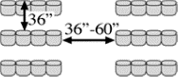
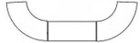
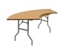
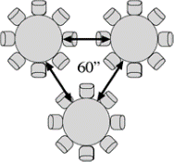
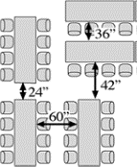
Chairs - Theater Style Seating
Allow a minimum of 36” between rows. Allow 36”-60” for aisles.
Table Seating Capacity:
6’x30” Rectangle: Seats 6
8’x30” Rectangle: Seats 8 -10
5’ (60”) Round: Seats 8

Serpentine tables are a great way to do your head table! They take up less room than doing tables all in a row.
Rectangular Tables
Allow a minimum of 60” between rectangular tables for chair and service space.
This permits 24” service space behind 18” chair depth.

